**Date-**

**Assignment No. :**

**Problem Statement:**

Program in C to find the minimum spanning tree from a given graph G by Prim’s Algorithm.

**Theory:**

We have discussed [Kruskal’s algorithm for Minimum Spanning Tree](https://www.geeksforgeeks.org/archives/26604). Like Kruskal’s algorithm, Prim’s algorithm is also a [Greedy algorithm](https://www.geeksforgeeks.org/archives/18528). It starts with an empty spanning tree. The idea is to maintain two sets of vertices. The first set contains the vertices already included in the MST, the other set contains the vertices not yet included. At every step, it considers all the edges that connect the two sets, and picks the minimum weight edge from these edges. After picking the edge, it moves the other endpoint of the edge to the set containing MST.  
A group of edges that connects two set of vertices in a graph is called [cut in graph theory](http://en.wikipedia.org/wiki/Cut_%28graph_theory%29). So, at every step of Prim’s algorithm, we find a cut (of two sets, one contains the vertices already included in MST and other contains rest of the verices), pick the minimum weight edge from the cut and include this vertex to MST Set (the set that contains already included vertices).

 The idea behind Prim’s algorithm is simple, a spanning tree means all vertices must be connected. So the two disjoint subsets (discussed above) of vertices must be connected to make a Spanning Tree. And they must be connected with the minimum weight edge to make it a Minimum Spanning Tree.

The algorithm may informally be described as performing the following steps:

1. Initialize a tree with a single vertex, chosen arbitrarily from the graph.
2. Grow the tree by one edge: of the edges that connect the tree to vertices not yet in the tree, find the minimum-weight edge, and transfer it to the tree.
3. Repeat step 2 (until all vertices are in the tree).

As described above, the starting vertex for the algorithm will be chosen arbitrarily, because the first iteration of the main loop of the algorithm will have a set of vertices in Q that all have equal weights, and the algorithm will automatically start a new tree in F when it completes a spanning tree of each connected component of the input graph. The algorithm may be modified to start with any particular vertex s by setting C[s] to be a number smaller than the other values of C (for instance, zero), and it may be modified to only find a single spanning tree rather than an entire spanning forest (matching more closely the informal description) by stopping whenever it encounters another vertex flagged as having no associated edge.

**Algorithm:**

**Input specification:**

1. I : The incidence matrix of dimension (n x n) of the given graph
2. vs : The source vertex to start the search from

**Output specification:**

1. A two dimensional array I[1..n][1..n] whose starting index is 1 and ending index is n, size of the array being (n x n).
2. A stack to store the intermediate vertices, say S.

**Steps:**

1. Repeat through Step 2 to Step For i=1 to N
2. Selected[i]=FALSE
3. Set i=i+1

[End of For loop]

1. Repeat through Step 2 to Step For i=1 to N
2. Repeat through Step 2 to Step For j=1 to N
3. Tree[i][j]=0
4. Set j=j+1

[End of inner For loop]

1. Set i=i+1

[End of outer For loop]

1. Selected[1]=TRUE, ne=1
2. Repeat through Step 11 to Step While(ne<N)
3. min=Infinite
4. Repeat through Step 2 to Step For i=1 to N
5. If(Selected[i]=TRUE) Then
6. Repeat through Step 2 to Step For j=1 to N
7. If(Selected[j]=FALSE) Then
8. If(min>Gptr[i][j]) Then
9. Set min=Gptr[i][j]
10. Set x=i ,y=j

[End of inner If structure]

[End of outer If structure]

[End of inner For loop]

[End of If structure]

[End of outer For loop]

1. Tree[x][y]=1
2. Selected[y]=TRUE
3. Ne=ne+1

[End of While loop]

1. Return (TREE)

**Source Code:**

#include <stdio.h>

#include <stdbool.h>

#include <stdlib.h>

#include <limits.h>

#define inf INT_MAX

int ** make_2d(int n){

int ** matrix = (int **)malloc(sizeof(int *) * n);

for(int i = 0;i < n;i++)

matrix[i] = (int *)malloc(sizeof(int) * n);

return matrix;

}

int ** prims(int ** gptr, int n, int v0){

bool selected[n];

int ** tree = make_2d(n), i = 0, j = 0, ne = 0, min, x, y;

// Initializations

while(i < n)

selected[i++] = false;

for(i = 0;i < n;i++)

for(j = 0;j < n;j++)

tree[i][j] = 0;

selected[v0] = true, ne = 1;

// Finding the nearest neighbour of the selected vertex

while(ne < n){

min = inf;

for(i = 0;i < n;i++){

if(selected[i] == true){

for(j = 0;j < n;j++){

if(selected[j] == false){

if(min > gptr[i][j]){

min = gptr[i][j];

x = i, y = j;

}

}

}

}

}

tree[x][y] = 1;

selected[y] = true;

ne++;

}

return tree;

}

void print_2d(int ** matrix, int n){

for(int i = 0;i < n;i++){

for(int j = 0;j < n;j++){

if(matrix[i][j] == INT_MAX)

printf("-- ");

else

printf("%2d ", matrix[i][j]);

}

printf("\n");

}

}

int main(){

int n, v0;

printf("\nEnter number of vertices : ");

scanf("%d", &n);

int ** gptr = make_2d(n), ** tree = NULL;

printf("\n(If any two vertices is not connected by an edge, enter 0)");

printf("\n\n");

for(int i = 0;i < n;i++){

for(int j = 0;j < n;j++){

printf("\b\rEnter the weight between vertices %d and %d : ", (i + 1), (j + 1));

scanf("%d", &gptr[i][j]);

if(gptr[i][j] == 0)

gptr[i][j] = INT_MAX;

}

}

printf("\nEnter the starting vertex : ");

scanf("%d", &v0);

if(v0 < 1 || v0 > n){

printf("\nInvalid staring vertex %d!", v0);

goto freeall;

}

printf("\nThe weighted adjacency matrix of the given graph is : \n");

print_2d(gptr, n);

tree = prims(gptr, n, v0);

printf("\nThe adjacency matrix of the minimal spanning tree of the given graph is : \n");

print_2d(tree, n);

freeall:

for(int i = 0;i < n;i++){

free(gptr[i]);

if(tree != NULL)

free(tree[i]);

}

free(gptr);

if(tree != NULL)

free(tree);

printf("\n");

return 0;

}

**Input & Output:**

Input graph:

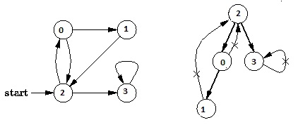

Output of program:

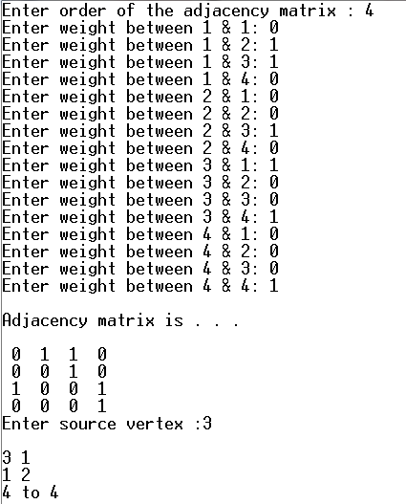

**Discussion:**

1. Setting a nodes ( with Stack ) label takes O( 1 ) time.
2. Each Nodes Is labeled twice:
   1. Once as Unexplored.
   2. Once as Visited.
3. Each Edge is labeled twice:
   1. Once as Unexplored.
   2. Once as Discovery or BACK.
4. Because the adjacency list of each nodes is scanned only when the nodes is Pop, each adjacency list is scanned at most once. Total time spent in scanning adjaceny list is O ( E ) [ in worst case ]. As initializations, takes O( V ) times, then total running time of DFS is O( V + E ).